This is a proposed cinema complex located in Dewata, Galle, in front of the A2 road, next to the southern coast. The land is one acre and highly valuable. The purpose is to design a theatre complex in Galle. However, due to the high value of the land, the decision was made to design an entertainment complex rather than just a theatre complex. The building has six storeys. The first three floors (ground floor, first floor, and second floor) are allocated for car parking, with capacities of 63, 54, and 54 cars, respectively. The fourth and fifth levels are allocated for restaurants, cafeterias, and gaming areas. The topmost level, the sixth floor, contains three theatres with seating capacities of 108, 200, and 136.The first three floors are 3.2 m high each, the next two floors are 4.2 m high each, and the topmost floor is 9 m high because cinemas require greater vertical clearance.
1. Ground-floor parking plan
One of the drawings is titled "GROUND LEVEL PARKING PLAN VIEW — 63 CARS". The ground-floor layout contains the following elements:
Parking bays, Individual parking spaces are represented by repeated rectangular divisions, mainly in magenta. Parking spaces are arranged in several rows around the circulation aisles. Preserve the positions, orientation, spacing and overall arrangement shown in the DWG. The drawing indicates 63 cars. Use this as a reference when checking the number of parking spaces.
Vehicle circulation, Green outlines indicate the main vehicle circulation routes or their boundaries. These include long straight sections and curved turns around the parking rows. Keep the aisles clear and preserve the intended circulation layout.
Ramp system, The upper-right portion of the drawing contains curved vehicle routes labelled "UP" and "DOWN". These labels indicate the intended directions of vehicle movement. Study the actual DWG geometry to understand how the ramp routes are arranged and how they connect to other levels. ramp is a simple circular spiral. Determine the ramp's shape, position, direction, starting and ending points, elevation change and slope from the available information. If the DWG does not provide enough information to determine its vertical geometry, like slab thicknesses wall thicknesses. Use the values within rules and regulations. In a way it is acceptable.
Lifts,The rectangular shapes with crossed diagonals represent lift locations. These are lifts, not columns. Columns are marked in the dwg file in a layer called columns. In the drawing it shows in small squares in light blue color. Create suitable lift shafts at their correct positions and dimensions where the drawing provides sufficient information. Keep the shafts aligned vertically between floors where appropriate.
Service areas, The right-hand side includes areas labelled "STP" and "CHILLER". STP refers to the sewage treatment plant. Preserve these service areas and their boundaries.
Other elements, A staircase-like arrangement and a room labelled "Main Service" appear near the lower-left portion of the parking plan. Preserve their locations and model them appropriately where enough information is available.
2. First- and second-level parking plan
One of the drawings is titled "FIRST & SECOND LEVEL PARKING PLAN VIEW — 54 CARS". The first- and second-level parking layout contains the following elements:
Parking bays, Individual parking spaces are represented by repeated rectangular divisions, mainly in magenta. Parking spaces are arranged in several rows around the central circulation area. Preserve the positions, orientation, spacing and overall arrangement shown in the DWG. The drawing indicates 54 cars on each level. Use this as a reference when checking the number of parking spaces.
Vehicle circulation, Green outlines indicate the main vehicle circulation routes or their boundaries. These include long straight sections and curved turns around the parking rows. Keep the aisles clear and preserve the intended circulation layout.
Ramp system, The central area contains a large circular ramp system with an elongated loop shape and curved ends. This is a key feature of the parking layout. The ramp follows a continuous loop around the central parking area, with long, nearly straight sections connected by curved turns. Clearly identify and model this circular ramp according to the actual DWG geometry. Do not simplify it into a straight ramp or a rectangular shape. Study the "UP" and "DOWN" labels and the ramp geometry to determine the intended vehicle movement and connections between levels. Determine the ramp's shape, position, direction, starting and ending points, elevation change and slope from the available information. If the DWG does not provide enough information to determine its vertical geometry, slab thicknesses or wall thicknesses, use values that comply with applicable building rules and regulations and are reasonable for this type of structure.
Lifts, The rectangular shapes with crossed diagonals represent lift locations. These are lifts, not columns. Columns are marked in the DWG in a layer called "columns". In the drawing, they appear as small squares in light blue. Create suitable lift shafts at their correct positions and dimensions where the drawing provides sufficient information. Keep the shafts aligned vertically between floors where appropriate.
Other elements, Preserve the external boundaries and other structural or architectural elements shown in the DWG. Maintain the correct alignment and positioning of the parking layout and circulation routes. Do not add unnecessary elements or change the existing arrangement.
3. First-floor restaurant and facilities plan (first and second floor plans)
The drawing shows a floor intended for restaurants and other facilities.
Columns and walls, Columns are represented by small squares in light blue and are marked in the DWG layer named "columns". Preserve the positions, dimensions, spacing and alignment of all columns shown in the drawing. Model the walls according to the wall layouts and boundaries shown in the DWG. Keep the columns and walls correctly aligned with the overall building layout.
Staircases, A staircase is located near the left-hand side of the drawing. Preserve its position, shape and dimensions as indicated in the DWG. Model the staircase appropriately in Revit to provide access between floors.
Lifts ,The rectangular shapes with crossed diagonals represent lift locations, not columns. Preserve their positions and dimensions, and create lift shafts that align vertically with the other floors where appropriate.
Restaurant and other facilities, Preserve the layout and arrangement of the spaces shown in the DWG. Follow the existing boundaries and dimensions when modelling the floor. Retain the columns, walls, staircase and lift locations in their correct positions.
General modelling requirements, Use the DWG as the main reference for all dimensions, geometry and element positions. Do not change the existing layout or add unnecessary elements.Ensure that the columns, walls, staircase and lift shafts align correctly with the other floors of the building.
4. Third-floor cinema plan
The drawing is titled "THIRD FLOOR PLAN VIEW" and contains three cinema theatres. Carefully identify the orientation of each theatre, the screen locations, seating arrangements and circulation areas from the DWG. Do not rotate, rearrange or misinterpret the theatres. The floor height is about 9m so when adding the seats carefull with those each rows columns of seating area heights suitable for a cinema .
Cinema theatres and seating, The drawing contains three separate cinema auditoriums, represented by groups of closely arranged seating rows shown mainly in magenta. The first auditorium is located in the upper-left portion of the plan. The second auditorium is located in the upper-middle portion of the plan. The third auditorium is located in the lower-right portion of the plan. Preserve the exact orientation, shape, position and arrangement of each auditorium according to the DWG. The seating rows must face the correct screen in each theatre. Carefully inspect the DWG to identify the screen position and the direction in which the seats face. The three theatres have seating capacities of 108, 200 and 136 seats, respectively. Use the DWG and these capacities to check the seating arrangements.
Screens, Identify the screen belonging to each auditorium from the actual DWG geometry and layers. Place each screen at the correct end of its auditorium, facing the seating rows. Do not assume that all three screens face the same direction. Determine their individual orientations from the drawing. Keep the screens and seating layouts correctly aligned.
Circulation areas, Preserve the aisles between seating blocks and the clear circulation spaces around each auditorium. Maintain the access routes connecting the auditoriums to the common circulation areas. Keep the spaces near the staircases and lifts unobstructed. Do not place seats, walls or other elements in the circulation areas shown in the DWG.
Walls, columns, lifts and staircases, Model the auditorium walls and other room boundaries according to the DWG. Columns are marked in the DWG layer named "columns" and appear as small light-blue squares. Preserve their correct positions. The rectangular shapes with crossed diagonals represent lifts, not columns. Keep the lift shafts in their correct locations and aligned vertically with the other floors. Preserve the staircase near the left-hand side of the plan and the other access elements shown in the drawing.
General modelling requirements, Use the DWG as the main reference for the geometry, dimensions, orientation and arrangement of all three theatres.Carefully distinguish the seating blocks, screens, aisles, circulation spaces, walls, columns, lifts and staircases. Do not guess the screen positions or rotate the auditoriums based only on the screenshot. Inspect the actual DWG layers and geometry wherever possible. Do not add unnecessary elements or change the existing layout. Ensure the three cinema auditoriums are clearly separated and modelled in their correct orientations in Revit.
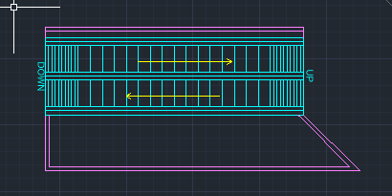 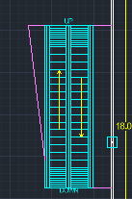 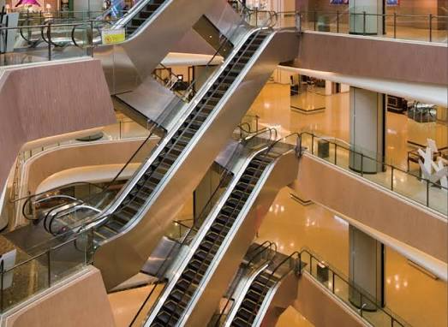 those drawing elements lines represents something similar to this.
Additional things if needed
